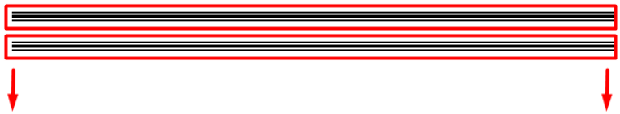

###################################################################

تمام تعالى نعرض براء فى controller ونشوف ازى اقدر اعرض الحاجات الى فى الموفع جوه فى الCp

وزى نقدر نعرض من الجداول ؟؟

بسم الله …

اول حاجه هتعامل عادى وكمان هرواح اعمل controller R عشان نعرض عليه الداتا

تمام ب تمام تطلع الموضوع بسيط جدااااااااااااااااااااا وسهل كمان ..... هو كل الفكره انك بتجيب الموديل وتحملو فى متغير وبقول all() وبكده هو هيتحمل الداتا بتعتو كلها و تعملو foreach

وتعرض بيه عادى جد ا

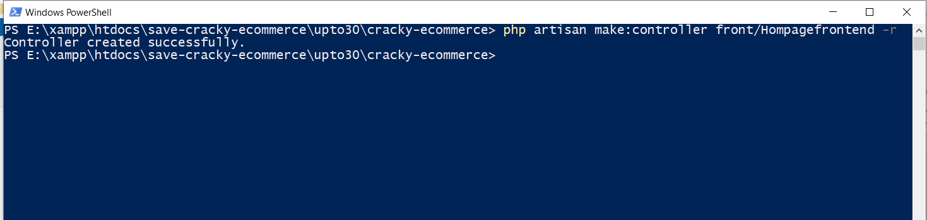

php artisan make:controller front/Hompagefrontend -r

<?php  
  
namespace App\Http\Controllers;  
use App\Model\Product;  
use App\Frontend;  
use App\Model\Department;  
use App\Slider;  
use Illuminate\Http\Request;  
use App\Http\Controllers\Controller;  
use Session;  
use DB;  
class Hompagefrontend extends Controller  
{  
 */**  
 * Display a listing of the resource.  
 *  
 \** ***@return*** *\Illuminate\Http\Response  
 */* public function index()  
 {   
 // ...................................  
 // $products_last_record = DB::table('products')->orderBy('id', 'DESC')->first();  
 $products_last_record = Product::*orderBy*('created_at','DESC')->paginate(10);  
 $products_first_record = Product::*orderBy*('created_at','ASC')->paginate(10);  
 $products_paginate = Product::*paginate*(30);  
 $products = Product::*all*();  
   
 $products_paginate_footer_one = Product::*orderBy*('created_at','DESC')->paginate(12);  
 $products_paginate_footer_two = Product::*orderBy*('created_at','ASC')->paginate(12);  
   
 // ...................................  
 $products = Product::*all*();  
 $frontends = Frontend::*all*();  
 $sliders_all = Slider::*orderBy*('created_at','DESC')->paginate(6);  
 $departments = Department::*all*();  
 $departments_paginate = Department::*orderBy*('created_at','DESC')->paginate(5);  
 // session()->forget('lingfront');   
 return view('front.index',[  
 'departments' =>$departments,  
 'sliders_all' =>$sliders_all,  
 'products' =>$products,  
 'products_last_record' =>$products_last_record,  
 'products_first_record' =>$products_first_record,  
 'frontends' =>$frontends,  
 'products_paginate' =>$products_paginate,  
 'departments_paginate' =>$departments_paginate,  
 'products_paginate_footer_one' =>$products_paginate_footer_one,  
 'products_paginate_footer_two' =>$products_paginate_footer_two,  
  
 ]);  
  
  
 }

